WESTLAKE CROSS COUNTRY
Chaparral Distance Academy
Grades 5th-8th
May 31st – June 3rd
HCMS TRACK
8am-10am

Instructors

Ryan Sanderson

HEAD BOYS/GIRLS CROSS COUNTRY COACH HIILL COUNTRY M.S. Graduate of Southwestern University where he competed in track and cross country. Two time Academic All-Amercian, Three time All-Conference, and Two time All-Regional athlete. USA track and field Level 1 certified. Designer of multiple NCAA sanctioned cross country courses.
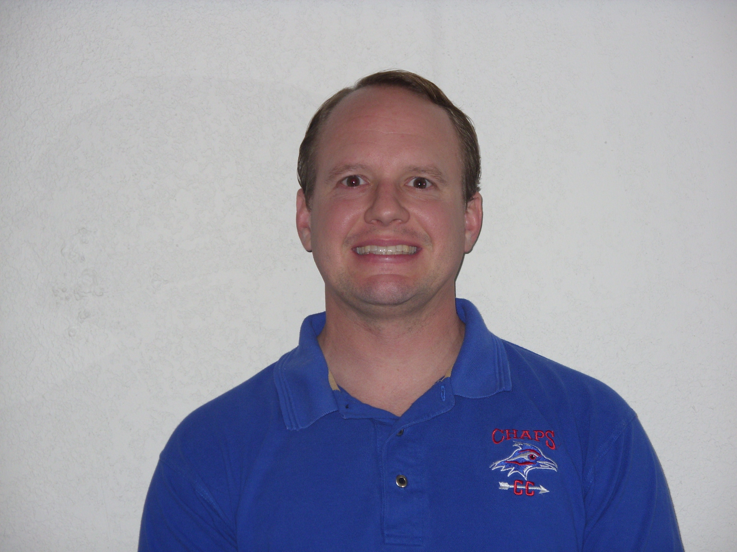

HEAD BOYS/GIRLS CROSS COUNTRY COACH WESTRIDGE M.S. Graduate of Texas State,, where he received his Bachelor’s Degree in Exercise/Sports Science. Has served as head coach 9 years, winning numerous district championships and sending athletes on to run at the varsity level.

Academy Instructors

Academy ation

PURPOSE
Provide young runners an opportunity
to learn proper running form, how to pace,
to hit goal times, and learn good running habits.

CAMP FOCUS
Form Running
Develop running base
Improve Strength
Proper running nutrition
Keeping a personal running log

Be part of a running tradition

You may register up to the start of camp on June 1st.

Registration Cost is $120 and includes camp t-shirt and running field trips.
All campers must register online through the Eanes Community Education web site.

The address is:

https://eanes.augusoft.net/index.cfm?method=ClassInfo.ClassInformation&int_class_id=8887&int_category_id=47&int_sub_category_id=187&int_catalog_id=0

Make checks payable to:
EISD

Pay by credit by visiting
http://eanes.augusoft.net/

QUESTIONS?

Ryan Sanderson
rsanderson@eanesisd.net
512.732.9140 ext. 23904
MEET AT
HCMS Track
May 31st – June 3rd

